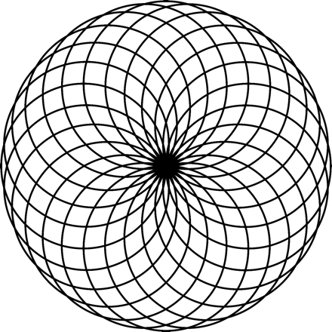

**Rosetta**

**Standards and Interfaces**

**Version 0.1**

**01 October 2024**

Table of Contents

Conventions Used in this Document 3

Standards 3

Stepper Motors 3

General 4

Stepper Motor Drivers 5

DC Power Supply 6

# Conventions Used in this Document

In this document,

* Standards are documented using green tables
* Recommendations are documented using blue tables

# Standards

## Stepper Motors

#### Spindle Stepper Motor

|  |  |  |
| --- | --- | --- |
| Item | Standard | Recommended |
| Size | NEMA 23 |  |
| Motor Type | Bipolar Stepper |  |
| Step Angle | 1.8 deg |  |
| Microstep Resolution | 6400 |  |
| Min. Holding Torque |  |  |
| Max. Rated Current/phase | 4A |  |

#### Other Stepper Motors

|  |  |  |
| --- | --- | --- |
| Item | Required | Recommended |
| Size | - n/a - | NEMA 23 or  NEMA 17 |
| Motor Type | Bipolar Stepper | Bipolar Stepper |
| Step Angle | 1.8 deg | 1.8 deg |
| Microstep Resolution | - n/a - | 6400 |
| Min. Holding Torque | - n/a - |  |
| Max. Rated Current/phase | 4A | 4A |

## General

1. Cabling

|  |  |  |
| --- | --- | --- |
| Item | Standard | |
| Conductor Type | | Stranded copper |
| Conductor Size | | 20 AWG |
| Cable Size | | 4 conductors / cable |

1. Connector

|  |  |  |
| --- | --- | --- |
| Item | Standard | |
| Connector | | GX-16, 4 pins |
| Cable Ends | | Female plug |
| Control Box | | Male Socket |

1. Connector Connection Standard & Cable Color Recommendation

|  |  |  |  |
| --- | --- | --- | --- |
| Pin | Use | Cable Wire Color | StepperOnline Stepper Motor Lead Color |
| 1 | A+ / A1 | Black | Black |
| 2 | A- / A2 | Yellow | Green |
| 3 | B+ / B1 | Red | Red |
| 4 | B- / B2 | White | Blue |

## Stepper Motor Drivers

1. Device

|  |  |  |
| --- | --- | --- |
| Item | Standard | |
| Model | | DM542T |

1. Power Cabling

|  |  |  |
| --- | --- | --- |
| Item | Standard | |
| Conductor Type | | Stranded copper |
| Conductor Size | | 20 or 22 AWG |
| Cable Size | | 2 conductors / cable |

1. Power Cabling Configuration

|  |  |
| --- | --- |
| Item | Cable Wire Color |
| Positive (+) | Red |
| Negative (-) | White (or Black) |

1. Signal Cabling

|  |  |  |
| --- | --- | --- |
| Item | Standard | |
| Conductor Type | | Stranded copper |
| Conductor Size | | 20 AWG |
| Cable Size | | 4 conductors / cable |

1. **Connectors**: Cable conductors are directly connected to the DM542T using the provided screw terminals.
2. Power Cabling Configuration

|  |  |  |
| --- | --- | --- |
| Item | Cable Wire Color | |
| Pulse + | | Black |
| Pulse - | | White (GND) * |
| Direction + | | Red |
| Direction - | | White (GND) * |
| Enable + | | Yellow |
| Enable - | | White (GND) * |

* GND wires tied / bonded together.

## DC Power Supply

1. Device

|  |  |  |
| --- | --- | --- |
| Item | Standard | |
| Model (USA) | | Mean Well EDR-120-24 |
| Input | | 120 VAC |
| Output | | 24 VDC |

1. DC Power Cabling

|  |  |  |
| --- | --- | --- |
| Item | Standard | |
| Conductor Type | | Stranded or solid copper |
| Conductor Size | | 20 or 22 AWG |
| Cable Size | | 2 conductors / cable |

1. DC Power Cabling Configuration

|  |  |  |
| --- | --- | --- |
| Item | Cable Wire Color | |
| Positive (+) | | Red |
| Negative (-) | | White (or Black) |

1. AC Power Cabling

|  |  |  |
| --- | --- | --- |
| Item | Standard | |
| Conductor Type | | Stranded copper |
| Conductor Size | | 16 AWG (min) |
| Cable Size | | 3 conductors / cable |

1. AC Power Cabling Configuration

|  |  |  |
| --- | --- | --- |
| Item | Cable Wire Color | |
| Hot (or live or active) | | Black |
| Neutral | | White |
| Ground | | Green |

1. **AC Power Switching Configuration**: Hot (or live or active) is switched on the infeed to the DC power supply.

To the extent that material may appear to be infringed, we assert that such alleged infringement is permissible under fair use principles in U.S. copyright laws. If you believe material has been used in an unauthorized manner, please contact me at [ColvinTools@Gmail.com](mailto:ColvinTools@Gmail.com).